Week 1 Task: Foundations of Computer-Aided Design (CAD)

1. Introduction & Overview of CAD
Computer-Aided Design (CAD) is the use of computer-based software to assist in the creation, modification, analysis, and optimization of engineering designs. Replacing traditional manual drafting, CAD enables engineers, architects, and designers to create precise 2D vector drawings and 3D solid models. Modern CAD tools streamline the product development lifecycle by enhancing design accuracy, improving communication through detailed documentation, and reducing physical prototyping costs.

2. Overview of Key CAD Tools (AutoCAD, CATIA, Free CAD)
Different industries rely on specialized CAD platforms tailored to specific design needs:
- AutoCAD: Primarily used for precise 2D drafting, floor planning, and architectural layouts, offering industry-standard documentation capabilities.
- CATIA: An advanced parametric 3D CAD suite heavily utilized in aerospace and automotive industries for complex surface modeling and assembly design.
- FreeCAD: An open-source parametric 3D modeler designed for general engineering, product design, and mechanical modeling with custom workbench configurations.

3. Professional CAD Workflow & Working Environment
Professional CAD design follows a structured workflow: defining reference geometry, building basic 3D feature sketches, applying geometric constraints, and generating complete assemblies.
In this practical exercise, FreeCAD (Part Design Workbench) was utilized to model a parametric mechanical component using standard engineering workflows:
- Workspace & Unit Configuration: Set up the working environment using the standard unit system (mm, kg, s, °) and initialized a active body container within the Part Design workbench.
- Sketching & Geometric Constraints: Selected the XY-Plane to generate a closed 2D profile. Applied explicit dimensional constraints (lengths and radii) along with geometric constraints (coincident, horizontal, and vertical) to ensure a fully defined sketch profile.
- Parametric Feature Operations: Utilized the Pad (Extrude) tool to transform the fully constrained 2D sketch into a 3D solid model. Applied secondary operations such as Pocketing and Filleting to complete feature details.
- Verification & Export: Verified geometry alignment across standard orthographic (Front, Top, Side) and Isometric views before exporting final design files and project documentation.

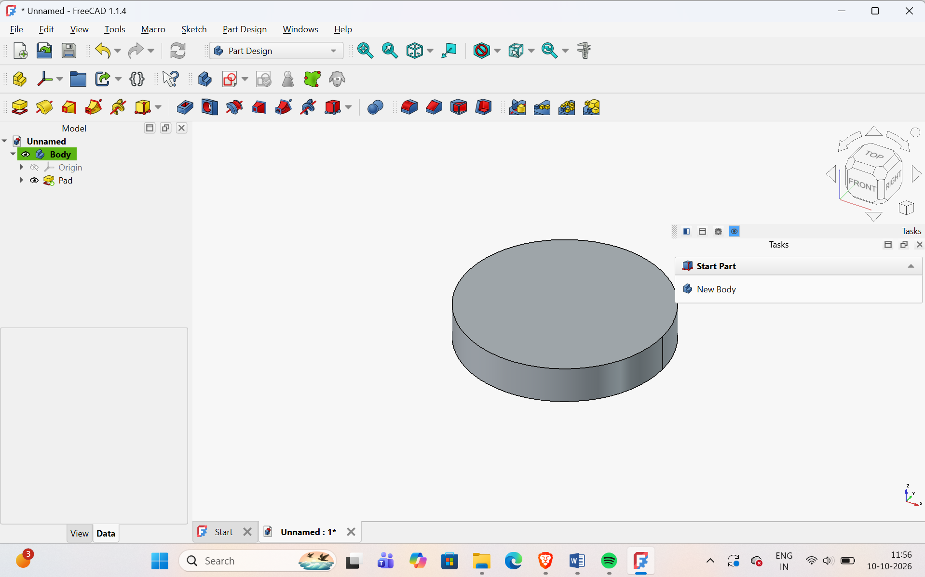

Figure 1: Verified local working setup in FreeCAD parametric 3D modeling environment.

